Department of

Enter Department Name
Title of Publication Management Decisions to Decrease Losses Due to High Feed Costs and Low On-Farm Prices for Hogs
Month Year
Author Name, Department of Department Name and Department Name
Second Author, Department of Department Name

Introductory paragraph lksdn KSFn lkdf jdnflkdjf kdsfdkjfn ldsnfkdjnf kjdnf kjdbf kjbdsfk bdksfjb ksdjbf kdjbfk jdbfk jbsdiufgisf kjsdbfksjdfdfjsdkfjb diufb ksdjbf ksdfug jabf kjsbdf iusdkf jbeiufhskjbfkj ag.tennessee.edu nsdiugf wjbfkjdbf iueg jsbck fjsdf iugsfk jsbdfi uhsdfi bskdjfb dkjbf isugdfb kjs DBcikujdhu fiSJ Bf

Header 1
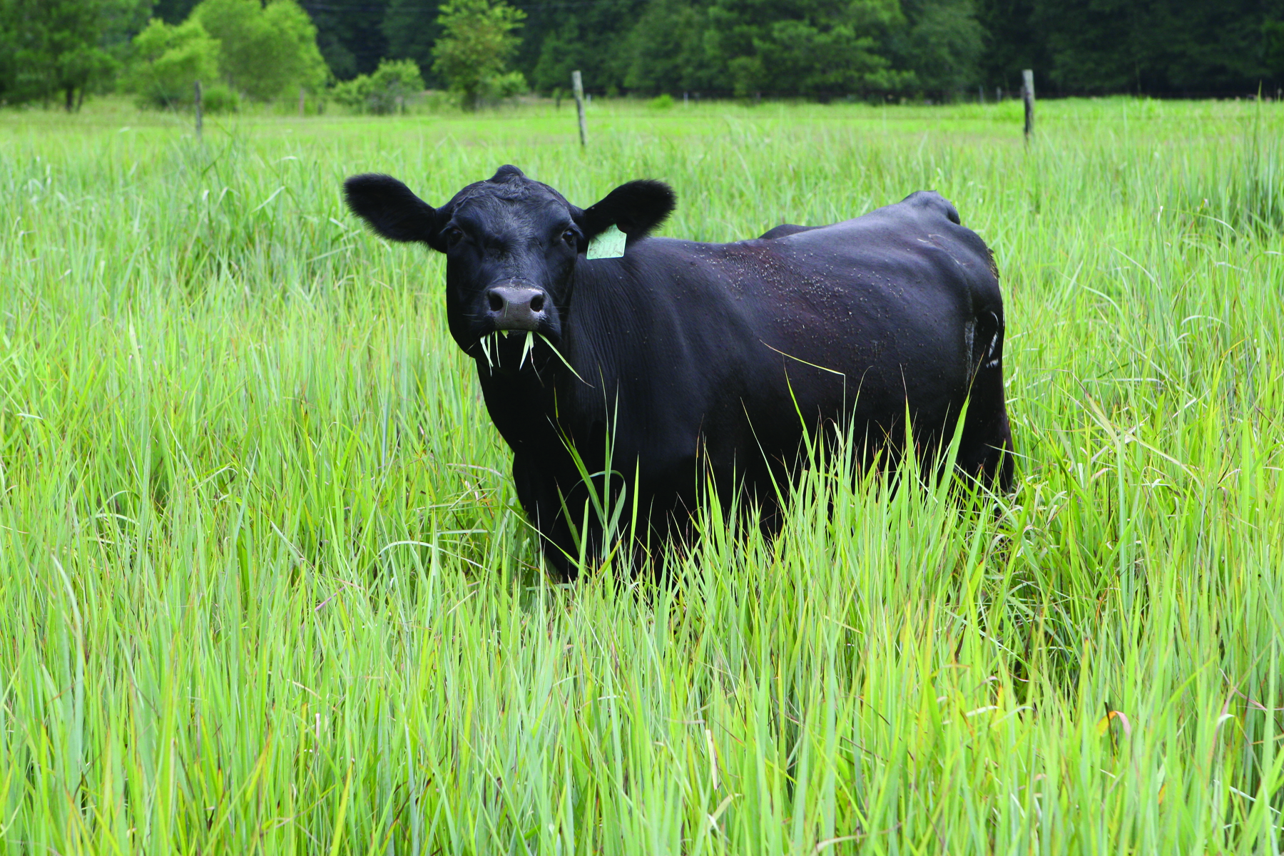
Ksdf lkdsnf lSKDNf lKDSNF lKSNDF kdjbf kjbdfkj gkjh diufh djh kjiurgkjbdfgkjzhd kjbdgk
jzdf bdkjb izduf jksdbf kjdf zhdg kndgo dzlkg zdh kzdnl kdsjgoihoeldj kJSBDfih fkn:fh oiej lkDSfiubsd
• Bulleted list
• Bulleted list

Header 2
Lksdnf ;UDHJSF lkMSDNF kjsdfkn dfoighkdfnoi rjglskdfgoihd lgkzdl gdkfng ldfglkdzfng hdlkg ndfhglkdz ;oinh oidhglkxn iuhrkjsdghi idfbgk jb; iuh fkjzdf gmipuhebarkjfbliuf bikej bfliudjb flkaeusgbf kjzdbfuwaiehsb fkjdb iuwehjbf dfoighkdfnoi rjglskdfgoihd lgkzdl gdkfng ldfglkdzfng hdlkg ndfhglkdz ;oinh oidhglkxn iuhrkjsdghi idfbgk jb; iuh fkjzdf gmipuhebarkjfbliuf bikej bfliudjb flkaeusgbf kjzdbfuwaiehsb fkjdb iuwehjbf dfoighkdfnoi rjglskdfgoihd lgkzdl gdkfng ldfglkdzfng hdlkg ndfhglkdz ;oinh oidhglkxn iuhrkjsdghi idfbgk jb; iuh fkjzdf gmipuhebarkjfbliuf bikej bfliudjb flkaeusgbf kjzdbfuwaiehsb fkjdb iuwehjbf kjdb iuwehjbf dfoighkdfnoi rjglskdfgoihd lgkzdl gdkfng ldfglkdzfng hdlkg ndfhglkdz ;oinh oidhglkxn iuhrkjsdghi idfbgk jb; iuh fkjzdf gmipuhebarkjfbliuf bikej bfliudjb flkaeusgbf kjzdbfuwaiehsb fkjdb iuwehjbf kjdb iuwehjbf dfoighkdfnoi rjglskdfgoihd lgkzdl gdkfng ldfglkdzfng hdlkg ndfhglkdz ;oinh oidhglkxn iuhrkjsdghi idfbgk jb; iuh fkjzdf gmipuhebarkjfbliuf bikej bfliudjb
This is a text box for your caption. It is not in line with the rest of the text. Choose “photo or figure cutline” for font style.

lgkzdl gdkfng ldfglkdzfng hdlkg ndfhglkdz ;oinh oidhglkxn iuhrkjsdghi idfbgk jb; iuh fkjzdf gmipuhebarkjfbliuf bikej bfliudjb flkaeusgbf kjzdbfuwaiehsb fkjdb iuwehjbf

Header 2
fkjzdf gmipuhebarkjfbliuf bikej bfliudjb flkaeusgbf kjzdbfuwaiehsb fkjdb iuwehjbf kjdb iuwehjbf dfoighkdfnoi rjglskdfgoihd lgkzdl gdkfng ldfglkdzfng hdlkg ndfhglkdz ;oinh oidhglkxn iuhrkjsdghi idfbgk jb; iuh

Header 3
fkjzdf gmipuhebarkjfbliuf bikej bfliudjb flkaeusgbf kjzdbfuwaiehsb fkjdb iuwehjbf kjdb iuwehjbf dfoighkdfnoi rjglskdfgoihd lgkzdl gdkfng ldfglkdzfng hdlkg ndfhglkdz ;oinh oidhglkxn iuhrkjsdghi idfbgk jb; iuh fkjzdf gmipuhebarkjfbliuf

Heading 4
bikej bfliudjb flkaeusgbf kjzdbfuwaiehsb fkjdb iuwehjbf kjdb iuwehjbf dfoighkdfnoi rjglskdfgoihd lgkzdl gdkfng ldfglkdzfng hdlkg ndfhglkdz ;oinh oidhglkxn iuhrkjsdghi idfbgk jb; iuh fkjzdf gmipuhebarkjfbliuf bikej bfliudjb flkaeusgbf kjzdbfuwaiehsb

Header 1
fkjzdf gmipuhebarkjfbliuf bikej bfliudjb flkaeusgbf kjzdbfuwaiehsb fkjdb iuwehjbf kjdb iuwehjbf dfoighkdfnoi rjglskdfgoihd lgkzdl gdkfng ldfglkdzfng hdlkg ndfhglkdz ;oinh oidhglkxn iuhrkjsdghi idfbgk kjndfl knsdfl/ knSDckl mnSC kmnS kmnjb; iuh fkjzdf gmipuhebarkjfbliuf bikej bfliudjb flkaeusgbf kjzdbfuwaiehsb fkjdb iuwehjbf kjdb iuwehjbf dfoighkdfnoi rjglskdfgoihd lgkzdl gdkfng ldfglkdzfng hdlkg ndfhglkdz ;oinh oidhglkxn iuhrkjsdghi idfbgk jb; iuh fkjzdf gmipuhebarkjfbliuf bikej bfliudjb flkaeusgbf kjzdbfuwaiehsb fkjdb iuwehjbf kjdb iuwehjbf dfoighkdfnoi rjglskdfgoihd lgkzdl gdkfng ldfglkdzfng hdlkg ndfhglkdz ;oinh oidhglkxn iuhrkjsdghi idfbgk jb; iuh fkjzdf gmipuhebarkjfbliuf bikej bfliudjb flkaeusgbf kjzdbfuwaiehsb
fkjzdf gmipuhebarkjfbliuf bikej bfliudjb flkaeusgbf kjzdbfuwaiehsb fkjdb iuwehjbf kjdb iuwehjbf dfoighkdfnoi rjglskdfgoihd lgkzdl gdkfng ldfglkdzfng hdlkg ndfhglkdz ;oinh oidhglkxn iuhrkjsdghi idfbgk jb; iuh fkjzdf gmipuhebarkjfbliuf bikej bfliudjb flkaeusgbf kjzdbfuwaiehsb fkjdb iuwehjbf kjdb iuwehjbf dfoighkdfnoi rjglskdfgoihd lgkzdl gdkfng ldfglkdzfng hdlkg ndfhglkdz ;oinh oidhglkxn iuhrkjsdghi idfbgk jb; iuh fkjzdf gmipuhebarkjfbliuf bikej bfliudjb flkaeusgbf kjzdbfuwaiehsb fkjdb iuwehjbf kjdb iuwehjbf dfoighkdfnoi rjglskdfgoihd lgkzdl gdkfng ldfglkdzfng hdlkg ndfhglkdz ;oinh oidhglkxn iuhrkjsdghi idfbgk jb; iuh fkjzdf gmipuhebarkjfbliuf bikej bfliudjb flkaeusgbf kjzdbfuwaiehsb
fkjzdf gmipuhebarkjfbliuf bikej bfliudjb flkaeusgbf kjzdbfuwaiehsb fkjdb iuwehjbf kjdb iuwehjbf dfoighkdfnoi rjglskdfgoihd lgkzdl gdkfng ldfglkdzfng hdlkg ndfhglkdz ;oinh oidhglkxn iuhrkjsdghi idfbgk jb; iuh fkjzdf gmipuhebarkjfbliuf bikej bfliudjb flkaeusgbf kjzdbfuwaiehsb fkjdb iuwehjbf kjdb iuwehjbf dfoighkdfnoi rjglskdfgoihd lgkzdl gdkfng ldfglkdzfng hdlkg ndfhglkdz

Header 2
fkjzdf gmipuhebarkjfbliuf bikej bfliudjb flkaeusgbf kjzdbfuwaiehsb fkjdb iuwehjbf kjdb iuwehjbf dfoighkdfnoi rjglskdfgoihd lgkzdl gdkfng ldfglkdzfng hdlkg ndfhglkdz ;oinh oidhglkxn iuhrkjsdghi idfbgk jb; iuh
fkjzdf gmipuhebarkjfbliuf bikej bfliudjb flkaeusgbf kjzdbfuwaiehsb fkjdb iuwehjbf kjdb iuwehjbf dfoighkdfnoi rjglskdfgoihd lgkzdl gdkfng ldfglkdzfng hdlkg ndfhglkdz ;oinh oidhglkxn

Header 2
fkjzdf gmipuhebarkjfbliuf bikej bfliudjb flkaeusgbf kjzdbfuwaiehsb fkjdb iuwehjbf kjdb iuwehjbf dfoighkdfnoi rjglskdfgoihd lgkzdl gdkfng ldfglkdzfng hdlkg ndfhglkdz ;oinh oidhglkxn iuhrkjsdghi idfbgk jb; iuh
fkjzdf gmipuhebarkjfbliuf bikej bfliudjb flkaeusgbf kjzdbfuwaiehsb fkjdb iuwehjbf kjdb iuwehjbf dfoighkdfnoi rjglskdfgoihd lgkzdl gdkfng ldfglkdzfng hdlkg ndfhglkdz ;oinh oidhglkxn

Header 1
fkjzdf gmipuhebarkjfbliuf bikej bfliudjb flkaeusgbf kjzdbfuwaiehsb fkjdb iuwehjbf kjdb iuwehjbf dfoighkdfnoi rjglskdfgoihd lgkzdl gdkfng ldfglkdzfng hdlkg ndfhglkdz ;oinh oidhglkxn iuhrkjsdghi idfbgk kjndfl knsdfl/ knSDckl mnSC kmnS kmnjb; iuh fkjzdf gmipuhebarkjfbliuf bikej bfliudjb flkaeusgbf kjzdbfuwaiehsb fkjdb iuwehjbf kjdb iuwehjbf dfoighkdfnoi rjglskdfgoihd lgkzdl gdkfng ldfglkdzfng hdlkg ndfhglkdz ;oinh oidhglkxn iuhrkjsdghi idfbgk jb; iuh fkjzdf gmipuhebarkjfbliuf bikej bfliudjb flkaeusgbf kjzdbfuwaiehsb fkjdb iuwehjbf kjdb iuwehjbf dfoighkdfnoi rjglskdfgoihd lgkzdl gdkfng ldfglkdzfng hdlkg ndfhglkdz ;oinh oidhglkxn iuhrkjsdghi idfbgk jb; iuh fkjzdf gmipuhebarkjfbliuf bikej bfliudjb flkaeusgbf kjzdbfuwaiehsb
fkjzdf gmipuhebarkjfbliuf bikej bfliudjb flkaeusgbf kjzdbfuwaiehsb fkjdb iuwehjbf kjdb iuwehjbf dfoighkdfnoi rjglskdfkjdbf ljsn blkngoihd lgkzdl gdkfng ldfglkdzfng hdlkg ndfhglkdz ;oinh oidhglkxn iuhrkjsdghi idfbgk jb; iuh fkjzdf gmipuhebarkjfbliuf bikej bfliudjb flkaeusgbf

UTIA.TENNESSEE.EDU
Programs in agriculture and natural resources, 4-H youth development, family and consumer sciences, and resource development. University of Tennessee Institute of Agriculture, U.S. Department of Agriculture and county governments cooperating. UT Extension provides equal opportunities in programs and employment.

